Exercise for Hypothesis testing

- It has been hypothesized that on average employees spend one hour a day playing video games at work. To test this at her company, a manager takes a random sample of 35 employees, who showed a mean time of 55 minutes per day, with an assumed population standard deviation of 5 minutes. Test the claim that the company's playing time differs from the national average at the significance level of 0.05.

Solution：1. H_{0：} µ=60 ，H_{a} ：µ ≠ 60
2.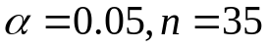
3. σ is known so this is a Z test.
4. For α = 0.05 the critical Z values are ±1.96
5. The test statistic is:
z = (55 - 60)/(5/√35) = -5/.845 = -5.916
6. Since -5.916<-1.96, then we can reject the null hypothesis and conclude the company's playing time differs from the national average at the significance level of 0.05
P-value approach:
Then we can reject the null hypothesis and conclude the company's playing time differs from the national average at the significance level of 0.05
- The HR department tested how long employees stay with the company in their current positions. A random sample of 50 employees yielded a mean of 2.79 years and σ = .76.Does the sample evidence indicate that the average time is less than 3 years and at α = .01.

Solution:
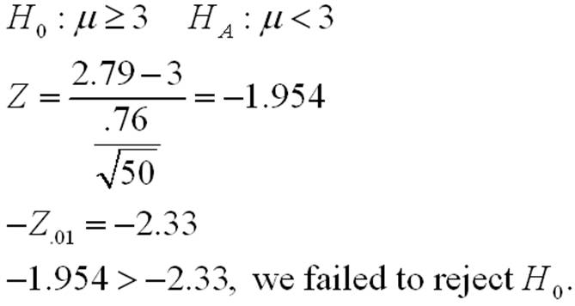
We don’t have enough evidence to say the average time is less than 3 years.

3. In a study of distances traveled by buses before the first major engine failure, a sample of 191 buses results in a mean of 96,700 miles and a population standard deviation of 37,500 miles. Calculate the p-value corresponding to the test statistic used to test the claim that the mean distance traveled before a major engine failure is more than 90,000 miles, and determine if the null hypothesis can be rejected at α = .01.
Solution:
z = (96,700 - 90,000)/(37,500/√191) = 6700/2713.4 = 2.469
Critical value 2.33,since 2.469>2.33,we can reject the null hypothesis.
p-value = 1 - .9932 = .0068
.0068 < .01; reject the null hypothesis.
The mean distance traveled before a major engine failure is more than 90,000 miles

- In research on cell phone use by teenagers, it was found that the average connect time for a call was at least 15 minutes. Social psychologists feel that this study understated the time. To determine this claim, cell phone bills for 15 teenagers were evaluated. On average, the time spent was 18.5 minutes, with a sample standard deviation of four minutes. (Assume a normal distribution.) What is the critical value for α = .001 to test the hypotheses. Determine whether the null hypothesis can be rejected at this level.
Solution: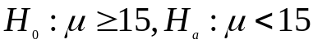
σ is unknown, so we use a t statistic
α = .001, this is left tail test. df=n-1=14.
The critical value is -3.787. t_{.001,14} = 3.787
The test statistic is t = (18.5 - 15)/4/√15) = 3.5/1.033 = 3.389
Cannot reject the null hypothesis, because 3.389 is greater than -3.787. Then we don’t have enough evidence to say the average connect time for a call was less than 15 minutes.

5. | A sample of 400 journalism majors at a major research university was asked if they agreed with the following statement: "Government should be more involved in oversight and regulation of reporting". Fifty-two percent of the respondents agreed with the statement. Use critical value and p-value approach to test if the agreed percentage is over 50% at 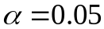?  Solution: 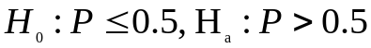  z = (.52 - .50)/√[(.50)(.50)/400] = .02/.025 = 0.80  Critical value for is 1.645, this is right tail test.  Since 0.8<1.645, we cannot reject the null hypothesis.  p-value = 1 - .7881 = .2119 This is not less than .05, so we cannot reject the null hypothesis.  We don’t have enough evidence to say the agreed percentage is over 50%.  - If you live in California, the decision to buy earthquake insurance is an important one. A survey revealed that only 133 of 337 randomly selected residences in one California county were protected by earthquake insurance. Use both critical value and p-value approach to test the claim that less than 40 percent of the county residents are protected by earthquake insurance at 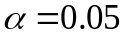?  Solution: 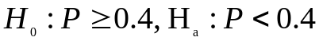  Critical value is -1.645.  z = (.3947 - .40)/√[(.4)(.6)/337] = -.0053/.0267 = -.1986  -1.645<-0.1986, we cannot reject the null hypothesis.  p-value =p(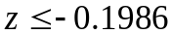) =0.4207  Since p-value is greater than 0.05, we cannot reject the null hypothesis.  We don’t have enough evidence to say less than 40 percent of the county residents are protected by earthquake insurance at  7.
  7. | Determine the p-value for H₀: p = .5; versus H_{A}: p ≠ .5, when n = 225 and 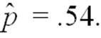  Solution: z = (.54 - .5)/√[(.5)²/225] = 1.21  p-value = 2(1 - .8869) = .2262

8. | A company has developed a new ink-jet cartridge for its printer that it believes has a longer lifetime on average than the one currently being produced. To investigate its length of life, 40 of the new cartridges were tested by counting the number of high-quality printed pages each was able to produce. The sample mean and standard deviation were determined to be 1511.4 pages and 35.7 pages, respectively. The historical average lifetime for cartridges produced by the current process is 1502.5 pages. At α = .05, test the claim that the new cartridge has a longer lifetime.  Solution: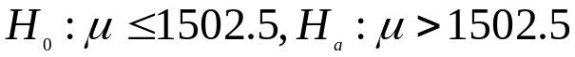  t = (1511.4 - 1502.5)/(35.7/√40) = 8.9/5.645 = 1.577  t_{.05} _{df} ₌ ₃₉ = 1.685  1.577 is not greater than 1.685.  Thus, we cannot reject the null hypothesis, and therefore cannot accept the claim that the lifetime of the new cartridge is greater.

